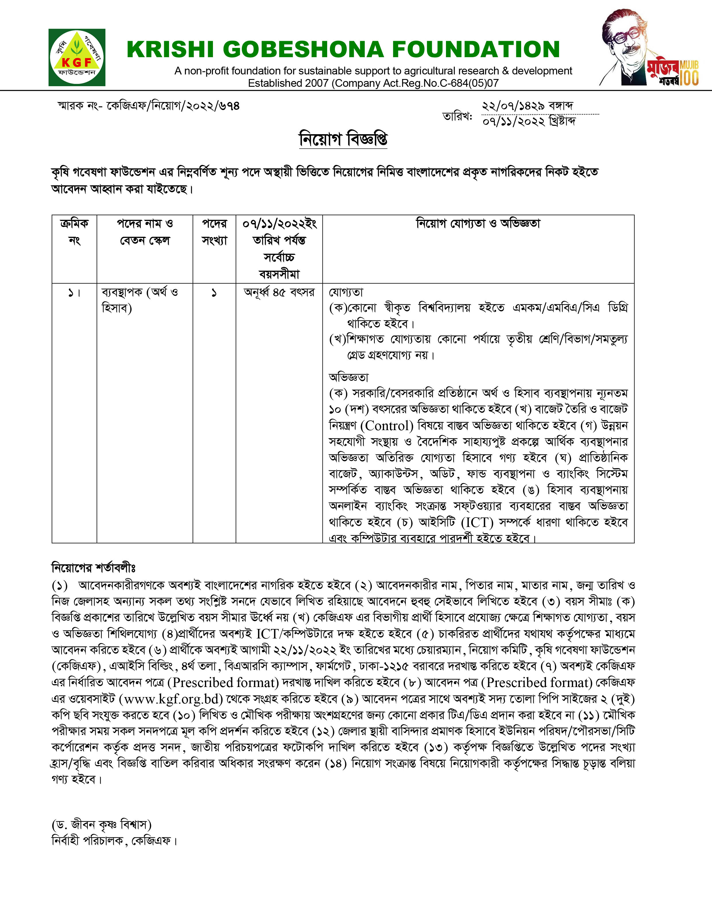

**Application Submission Form for the Position of**

Attach Photograph

**Professionals of KGF**

|  |  |  |  |  |  |  |  |  |  |  |  |  |  |
| --- | --- | --- | --- | --- | --- | --- | --- | --- | --- | --- | --- | --- | --- |
| **S/N** | **Applicant’s Information** | | | | | | | | | | | | |
| 1. | **Name of the position for applied**: | | | |  | | | | | | | | |
| 2. | Name of applicant:  Father’s Name:  Mother’s Name: | | | |  | | | | | | | | |
| 3. | **Mailing address with contact no:** | | | |  | | | | | | | | |
| 4. | **Permanent Address:** | | | |  | | | | | | | | |
| 5. | **Date of Birth:** | | | |  | | | | | | | | |
| **Age on 25/5/2021:** | | | | **Year: Month: Day:** | | | | | | | | |
| 6. | Nationality:  Religion: | | | |  | | | | | | | | |
| 7. | **Membership of professional society:** | | | |  | | | | | | | | |
| 8. | **Academic qualification:** | | | |  | | | | | | | | |
|  | School/ college/university attended | | | | Examination passed | | | Year | | | Division/Class/Grade (out of scale) obtained | | |
|  | | | |  | | |  | | |  | | |
|  | | | |  | | |  | | |  | | |
|  | | | |  | | |  | | |  | | |
|  | | | |  | | |  | | |  | | |
|  | | | |  | | |  | | |  | | |
| 9. | **Training Received:** | | | | | | | | | | | | |
|  | 1. In Country | | | | | | | | | | | | |
| i. | Name of Training | Duration (Days) | | | Institution & Country | | | Grade/Certificate/Diploma | | | | |
| ii. |  |  | | |  | | |  | | | | |
| iii. |  |  | | |  | | |  | | | | |
| iv. |  |  | | |  | | |  | | | | |
| v. |  |  | | |  | | |  | | | | |
| 1. Abroad/ Overseas | | | | | | | | | | | | |
| vi. |  |  | | |  | | |  | | | | |
| vii. |  |  | | |  | | |  | | | | |
| viii. |  |  | | |  | | |  | | | | |
| ix. |  |  | | |  | | |  | | | | |
| x. |  |  | | |  | | |  | | | | |
| 10. | **Languages and degree of proficiency: (Excellent/Very good/Good)** | | | | | | | | | | | | |
|  | Language | | | | Speaking | | Reading | | | | | Writing | |
|  | | | |  | |  | | | | |  | |
|  | | | |  | |  | | | | |  | |
|  | | | |  | |  | | | | |  | |
| 11. | **Employment/Service records (**Employer/ Employers Organization Name):  (please attach a list of service records/experience from last to first position following the same style) | | | | | | | | | | | | |
|  |  | | | Employer 1 | | | |  | | | | |  |
|  | Designation: | | | |  | | | | |  |
| Duration: | | | | From: | | | | | To: |
| Description of the duties (Not more than eight) | | | | | | | | | |
| i. | | | |  | | | | |  |
| ii. | | | |  | | | | |  |
| iii. | | | |  | | | | |  |
| iv. | | | |  | | | | |  |
| v. | | | |  | | | | |  |
| Employer 2 | | | |  | | | | |  |
| Designation: | | | |  | | | | |  |
| Duration: | | | | From: | | | | | To: |
| Description of the duties (Not more than eight) | | | | | | | | | |
| i. | | | |  | | | | |  |
| ii. | | | |  | | | | |  |
| iii. | | | |  | | | | |  |
| iv. | | | |  | | | | |  |
| v. | | | |  | | | | |  |
| *12. | **Number of publications: (please attach a list of publication)** | | | | | | | | | | | | |
|  | Scientific Papers:  As principal author:   1. National 2. International | | | As co-author:   1. National 2. International | | | | | | | | | |
| Popular articles: | | |  | | | | | | | | | |
| *13. | **Number of papers presented in different national & international seminars /symposiums/ workshops: (please attach a list of papers)** | | | | | | | | | | | | |
|  | National: | | | International: | | | | | | | | | |
| *14. | **Number of Projects prepared & implemented: (please attach a list of projects)** | | | | | | | | | | | | |
|  | Projects prepared: | | |  | | | | | | | | | |
| Projects implemented: | | |  | | | | | | | | | |
| Policy Papers: | | |  | | | | | | | | | |
| *15. | **Outstanding Achievements/ Contributions:** | | | | | | | | | | | | |
| 16. | A brief write-up justifying applicant’s suitability for this position: within 250-300 words. | | | | | | | | | | | | |
| 17. | Computer literacy: | | | | | |  | | |  | | | |
| 18. | Certification: | | | | | | | | | | | | |
| I, the undersigned, certify that to the best of my knowledge and belief, information provided in this application about myself, my qualifications and my experience are true. I also understand that any willful miss statement described herein may lead to my disqualification or dismissal, if engaged.  Signature:  Date : | | | | | | | | | | | | |

**\*For the post of Manager (Accounts & Finance) and Assistant manager(establishment), the serial number 12, 13 14 and 15 are not applicable.**